**World Quant University**

**Professor: Ivan Blanco**

**Alpha Design I**

Nikolas Lippmann Pareschi - [nikolaslippmann@gmail.com](mailto:nikolaslippmann@gmail.com)

**Assignment 4**

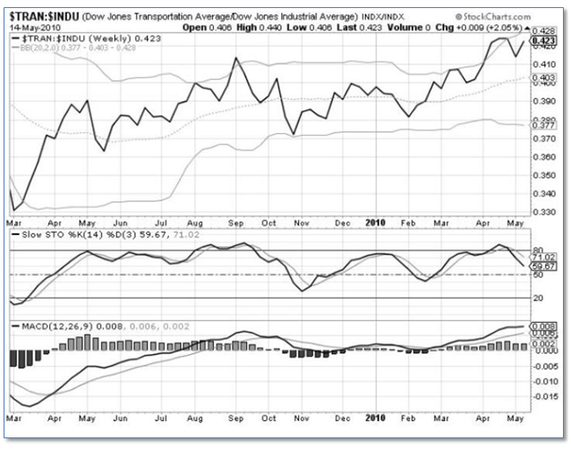

* Study the above for Dow Jones Transportation Average and Dow Jones Industrial Average.

The Dow Jones Transportation Average has the following compositions:

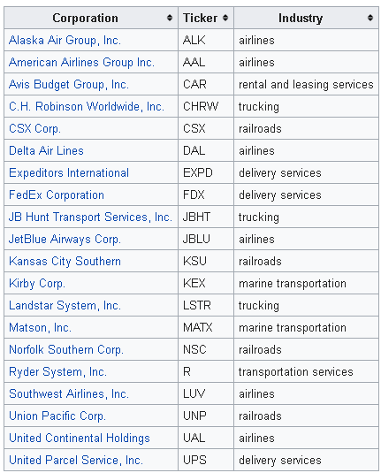

The Dow Jones Industrial Average has the following composition:

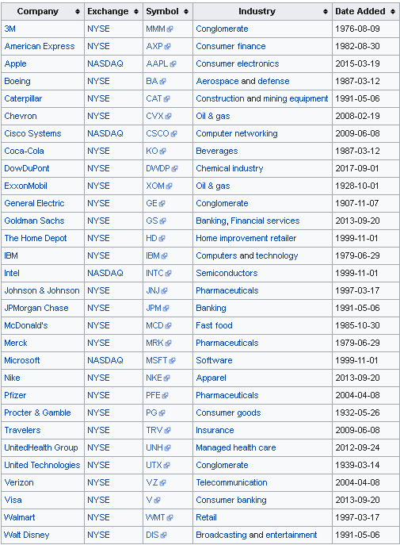

The chart is a time series of the division of Dow Jones Transportation Average by the Dow Jones Industrial Average.

* Make a note of the technical indicator panels provided – The stochastic and the Moving Average Convergence Divergence (MACD)

The stochastic oscillator momentum indicator [1] comparing the closing price of a security to the range of its prices over a certain period of time. The Moving Average Convergence/Divergence oscillator (MACD) turns two trend-following indicators, [moving averages](http://stockcharts.com/school/doku.php?id=chart_school:technical_indicators:moving_averages), into a momentum oscillator by subtracting the longer moving average from the shorter moving average. As a result, the MACD offers the best of both worlds: **trend following and momentum.** The MACD fluctuates above and below the zero line as the moving averages converge, cross and diverge. Traders can look for signal line crossovers, centerline crossovers and divergences to generate signals. Because the MACD is unbounded, it is not particularly useful for identifying overbought and oversold levels [2].Stocastich MACD are used in technical analysis as a way to enter normally in countertrend trades.

* Using all the technical information available, provide a pairs trading recommendation. Provide concrete reasoning to support your choice. Did the Stochastics and MACD help you in deciding on the direction of pairs trade? If not, which indicator would have been ideal?

We have 3 evidences appoint to support the idea of shorting the Dow Jones Transportation and going long the Dow Jones Industrial. Fist, we have the division of DJTransport x DJIndustrial next to the upper Bollinger band. Secondly and thirdly we have the stochastic oscillator and the MACD next to overbought levels.

* Write a Python program to download data for Dow Jones Transportation Average and Dow Jones Industrial Average for the last 5 Years.

Code:

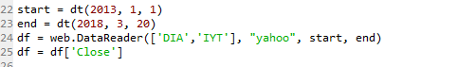

* Create and calculate any one indicator that would allow you to decide on making a pairs trade between these 2 indices.
* Based on the historical values of that indicator, calculate and graphically represent the return profile of a pairs trading strategy

Both questions answered at the same place. The indicator is the ratio between DJ Industrial and DJ Transports normalized. The strategy buys DJ Industrails and sells DJ Transports when the z-score is below -2 .The Strategy sells DJ Industrails and buy DJ Transports when the z-score is above 2. The strategy close the opened positions with the Z-Score between -1 and 1. We plot afterward a cumulative return graph.

